

**Market Power and Monetary Policy**

Speech given by

Andrew G Haldane Chief Economist Bank of England

Co-authors: Tommaso Aquilante, Shiv Chowla, Nikola Dacic, Riccardo Masolo, Patrick Schneider, Martin Seneca and Srdan Tatomir.

Federal Reserve Bank of Kansas City Economic Policy Symposium Jackson Hole, Wyoming

24 August 2018

The views expressed here are not necessarily those of the Bank of England or the Monetary Policy Committee. I would like to thank Federico Di Pace, Laure Fauchet, Rebecca Freeman,

Jeremy Leake, Clare Macallan, Colm Manning, Roland Meeks, Kate Reinold, Natalja Sekhan, Silvana Tenreyro, Jan Vlieghe and Robert Zymek for their comments and contributions.

This work contains statistical data from ONS which is Crown Copyright. The use of the ONS statistical data in this work does not imply the endorsement of the ONS in relation to the interpretation or analysis of the statistical data. This work uses research datasets which may not exactly reproduce National Statistics aggregates.

The topic for this panel is the link between developments in product markets and monetary policy. It is a great one. A lot of attention has been paid by central bankers over recent years to the relationship between *labour markets* and monetary policy (for example, Yellen (2014) and Constâncio (2017)). And rightly so.

The relationship between monetary policy and *product* markets has, by comparison, been the road less travelled.1,2

Labour markets have been subject to big structural shifts over recent years, including the secular fall in the degree of worker unionisation in a number of industries (for example, Schnabel (2013)), the emergence of the so-called “gig economy” (for example, Taylor (2017) and Katz and Krueger (2017)) and secular rise in the degree of globalisation and automation in the workplace (for example, Brynjolfsson and McAfee (2014) and Acemoglu and Restrepo (2018)). Each of these shifts has led to a change in employment patterns and tenures and in workers’ bargaining power.

These structural shifts have been used to help explain the secular fall in labour’s share of national income and the recent weakness of wage growth across a number of advanced economies (for example, Dao *et al* (2017) and Abdih and Danninger (2017)).3 They have also been used to justify potential shifts in the position and/or the slope of the Phillips curve (for example, Blanchard (2016) and Kuttner and Robinson (2010)).

Each of these potentially has a bearing on the setting of monetary policy.

Yet, over the same period, structural shifts in the product market have been no less profound. They include the emergence of highly-integrated global supply chains, increasing the degree of specialisation of product markets (Baldwin (2016)); the blossoming of companies benefitting from global network economies of scale and scope, who acquire “superstar” status (Autor *et al* (2017)); and the rapid emergence of e-commerce and price-comparison technology (Cavallo (2017)).

The associated shifts in market power, too, might plausibly have altered some of the key macro-economic relationships in the economy (De Loecker and Eeckhout (2017)). They may have influenced the pricing and provision of goods and services in the economy and hence the Phillips curve. And they may have influenced the amount of investment and innovation undertaken by firms and hence the aggregate demand curve (Aghion *et al* (2005)). They, too, might thus have a bearing on the setting of monetary policy.

These structural shifts in product and labour markets may, in some cases, have had common cause. For example, network economies of scale and scope could potentially have increased some companies’ market power both over their labour inputs (through monopsony effects) and product outputs (through monopoly effects). This could show up in both a *falling* labour and a *rising* profit share, with potential macro-economic implications for activity, costs and prices (Autor *et al* (2017), Barkai (2017)).

1 As Blanchard (2008) said, “How mark-ups move, in response to what, and why, is however nearly terra incognita for macro.”

2 Some notable papers that discuss the impact of product market developments on the macro-economy include Cacciatore and Fiori (2016) and Eggertsson, Ferrero and Raffo (2014).

3 Unlike many other advanced economies, it is worth noting that the UK labour share has not been on a downward trend.

To explore these issues, we start by discussing briefly recent empirical evidence on market power and its potential macro-economic explanations and implications. We then explore its effects on monetary policy, using counter-factual policy simulations and adaptations of a simple New Keynesian model. Taken together, this evidence suggests that an increase in market power and mark-ups could have potentially important consequences for the economy and policy. These are summarised, in stylised terms, in Figure 1.

To the extent a secular rise in mark-ups reflects a set of trade-off inducing shocks, that would shift outwards the output/inflation variability (policy possibility) frontier (from A to B). It may steepen the Phillips curve, causing the policy possibility frontier to rotate clockwise (B to C). And it may also potentially alter the optimal weights placed on output and inflation stabilisation by the policymaker, shifting the point of tangency between the policy possibility frontier and policymakers’ loss function (C to D).

Taken together, the net effect of increased market power could be a potentially significant rise in inflation (but less so output) variability, relative to the counterfactual case of stable and static mark-ups (A to D). As for monetary policy, the fact that these are trade-off inducing shock places limits on its stabilisation capacity.

The (level and variability) of the optimal interest rate path is, as a result, less affected by increased market power, despite significant shifts in policy possibility frontiers and policymaker preferences.

There are two ways in which the path of monetary policy might potentially be affected to a greater degree by increases in market power. When companies have a significant degree of market power, the level of output produced is likely to be below the social optimum, creating an incentive for monetary policy to try to offset that by running the economy hotter (“inflation bias”). And if market power lowered companies’ investment rates, this could reduce the economy’s neutral rate of interest. Neither, however, at present has a strong empirical basis. To the extent these channels do operate, they reinforce the institutional case for independent central banks charged with pursuing well-defined inflation targets.

At the same time, actual inflation across advanced economies has of course been relatively low and stable over recent decades. So while the micro-economic evidence – a secular increase in mark-ups – is striking, it is not easily reconciled with the macro-economic evidence on measured inflation, including on the impact of mark-ups on inflation (for example, Smets and Wouters (2007)). Reconciliation of the two strands of evidence – micro and macro – means that some combination of the following would have to be true.

First, the micro-economic *firm-level* evidence may not accurately describe how *economy-wide* mark-ups have evolved since the 1980s. Second, other macro-economic factors may have more than offset the impact of rising mark-ups on the behaviour of inflation. Third, the theoretical macro-economic framework we use here – a New Keynesian model with monopolistic competition – may not be appropriate to analyse firm-level changes in mark-ups. The apparent puzzle between the micro-economic and macro-economic evidence deserves further research, given its potential impact on inflation dynamics and monetary policy.

# Market Power – Evidence and Implications

There is a rich micro-economic literature that assesses the impact of market power on pricing and other firm decisions (for example, Tirole (1988)). There has been rather less evidence linking the industrial organisation of firms to developments in the wider macro-economy. That has changed recently, with a number of papers exploring the empirical evolution of (firm, sectoral and national) measures of market power and their implications for the macro-economy (for example, De Loecker and Eeckhout (2017, 2018) and Díez *et al* (2018)).

Perhaps the simplest way of capturing market power is through measures of market concentration, such as Herfindahl-Hirschman Indices (HHI) (Hirschman (1964)) or concentration ratios (the share of sales that accrues to the largest firms within an economy or sector). Evidence suggests that market concentration, measured either through HHIs or concentration ratios, may have increased in the US over recent decades, across a broad range of sectors (for example, Autor *et al* (2017)). This pattern is not uniform, however, with concentration among European companies showing no such trend (Gutiérrez and Philippon (2018)).

The evidence on industry concentration in the UK suggests it occupies a mid-Atlantic position. Chart 1 plots the turnover share of the largest 100 UK businesses since 1998 (i.e. concentration ratio).4 This ticks up in the lead-up to the financial crisis, although this pick-up is more modest than in the US, from 20% to around 28%.5 Concentration has flattened-off in the period since the crisis, however, in line with other European countries.

Turning to measures of concentration within the financial services industry, the international pattern is somewhat more uniform. Chart 2 plots the largest five banks’ share of total banking assets in the US, euro area and the UK. Levels of banking concentration started fairly high, averaging around 30%. They drifted further upwards in the run-up to the crisis, although this drift was again fairly modest. Since the crisis, however, measures of banking concentration have flat-lined and, in the UK, have fallen slightly.

Concentration indices have their limitations, though, and need not always be associated with market power. Some firms may be able to exercise market power in setting prices even without having a large share of a market if, for example, there is brand loyalty. And in a world of differentiated products, concentration measures such as HHIs or concentration ratios no longer correlate closely with market power (Bresnahan (1989)). With non-homogenous goods and non-Cournot competition, a better measure of market power is often provided by firms’ mark-ups – the ratio of their price to their marginal cost (De Loecker and Eeckhout (2018)). The larger the mark-up, the greater the degree of market power, whether at the firm, sector or national level. Mark-ups also have the benefit of being the relevant measure of market power in the workhorse models of the macro-economy used by policymakers.

4 Excluding financial services firms.

5 See, also, Bell and Tomlinson (2018).

In that spirit, a number of recent papers have estimated measures of mark-ups based on individual company accounts data. These cover a wide range of companies, sectors, countries and time periods (for example, Díez *et al* (2018)). The findings from these studies are, in macro-economic terms, both quite striking and quite strikingly uniform in the broad trends they reveal.

For example, De Loecker and Eeckhout (2018) have recently calculated mark-ups for around 70,000 firms across 134 countries over almost four decades.6 Since 1980, they estimate that the sales-weighted mark-up for the average firm across countries has risen by a remarkable 50 percentage points.7 Table 1 shows their mark-up measures for the G7 economies over the period. Though there is cross-country variation, average mark-ups have risen significantly in every G7 country, by between 30 and 150 percentage points.

Taken at face value, the macro-economic implications of these shifts in mark-ups could be very large. The most direct and immediate impact would be on measured inflation rates. According to Table 1, mark-ups will have been adding, on average, over one percentage point *each year* to measured inflation rates across the G7 countries between 1980 and 2016, other things equal. As context, over the same period average G7 inflation rates have fallen by over 10 percentage points.8

A second potential macro-economic impact of higher mark-ups is on sales. Higher mark-ups will, other things equal, have pushed down on aggregate demand and generated a deadweight loss of consumer surplus (“Harberger triangle”). Baquee and Farhi (2018) estimate the size of this effect and find that *eliminating* mark-ups entirely would raise aggregate US total factor productivity (TFP) by as much as 35%.9

To better understand some of the drivers of higher mark-ups, it is useful to look at more granular data. Using a similar approach to De Loecker and Eeckhout (2017, 2018), we draw on data for around 3,500 unique

UK-listed companies from the late-1980s to construct around 33,500 firm-year mark-up estimates.10 Using that methodology, Chart 3 plots a sales-weighted measure of mean mark-ups for UK-listed companies since 1987. It shows a striking rise, from 1.2 to around 1.6, over the period. This broadly mirrors international trends.

Although they capture subtly different dimensions of market power, there is a weakly positive relationship between measures of mark-up and market concentration at the sector level (Chart 4), which is statistically

6 De Loecker and Eeckhout (2018) use a dataset that largely includes publicly-traded companies, but there are also some privately held firms.

7 Similar estimates have recently been provided by Díez *et al* (2018).

8 OECD data.

9 De Loecker and Eeckhout (2018) estimate that mark-ups in the US are a little larger than in the UK, so the boost to UK TFP from eliminating them would be smaller than the 35% estimate for the US in Baquee and Farhi (2018), albeit of a similar order of magnitude.

10 The methodology is explained in the Appendix. The data include around a little over 1000 firms, on average, per year. These firms account for around one-third of UK employment. Their sales are equivalent to around one-third of UK turnover and around two-thirds of

UK nominal GDP. We exclude financial sector firms and, having estimated mark-ups, trim outliers, i.e. those firm-level mark-ups that are below the 1st percentile and above the 99th percentile of the firm-level mark-up distribution in a given year,

significant at the firm level.11 The same has been found among companies in other countries (Díez *et al* (2018)). This gives some degree of reassurance that the rise in measured market power has been a genuine one.

If we slice the mark-up data for non-financial companies on a sectoral basis, this suggests this rise has been reasonably broad-based (Chart 5). All but two of the ten sectors have seen mark-ups rise since 1987, although some are volatile. Six of the ten have seen them rise by more than 30 percentage points. Among the largest rises have been in manufacturing (70 percentage points), professional, scientific and technical (62 percentage points) and transport and storage (57 percentage points). This broadly mirrors the international evidence.12

One apparent exception is the banking sector. Chart 6 plots a measure of banks’ net interest margins (NIMs), as a proxy for mark-ups, in the UK, US and euro area since 1996. NIMs appear to have been broadly flat in these countries over recent decades. If anything, they may have fallen over the past decade. The latter is potentially the result of the low levels of official interest rates, constraining the ability of banks to lower their deposit rates in order to protect margins (for example, Claessens, Coleman and Donnelly (2017)).

Another way of slicing the data is to ask how much of the rise in mark-ups is due to a compositional shift over time towards sectors whose mark-ups are already high and how much reflects a generalised rise in mark-ups within each sector. Chart 7 shows this decomposition for UK-listed firms. Compositional effects do not explain any of the rise in mark-ups in the UK; and even if we do the same exercise at the firm level, compositional shifts towards firms with high mark-ups cannot explain the rise. Rather, the rise in mark-ups appears to be reasonably generalised across sectors.13

Although relatively broadly-based *across* sectors, the rise in mark-ups need not necessarily be broadly based *within* sectors. One way of showing that is by looking at the evolution of the distribution of mark-ups over time (Chart 8). This suggests the increase in mark-ups is heavily concentrated in the upper tail of the distribution – companies whose mark-ups are in, say, the top quartile. Mark-ups among firms in this upper quartile of the distribution have, on average, increased by a remarkable 50 percentage points since 1987.

By contrast, mark-ups among firms in the bottom three quartiles of the mark-up distribution have scarcely risen over the period. This distributional effect can also be seen from the large and widening gap between mean and median mark-ups (Chart 9). In 1987, this gap was 7 percentage points. By 2016, it had reached 44 percentage points. This strongly suggests that the rise in aggregate mark-ups over the past 30 years can largely be accounted for by a subset of high mark-up firms raising their mark-ups and/or market share.

11 While the positive *unconditional* correlation between average firm-level mark-ups and concentration at the sector level shown in Chart 4 is not statistically significant, a regression of individual firm-level mark-ups on market concentration in their sector (at the two-digit SIC level) shows a statistically significant positive relationship when we include firm and time fixed effects.

12 For example, Díez *et al* (2018) find that the majority of industries in the US have seen mark-ups rise since 1980.

13 Díez *et al* (2018) find that the increase in US mark-ups since 1980 is also relatively broad-based across sectors.

This fattening of the upper tail of the mark-up distribution is not uniform across sectors. Chart 10 plots a measure of the skew of the mark-up distribution across different sectors over time. The fattening of the upper tail of the distribution is most pronounced in the ICT, transport and storage and manufacturing sectors, each of which is associated with higher average levels of mark-up.

In understanding the characteristics of these firms, one revealing cut comes from taking into the account the extent to which UK-based firms’ sales are domestic or foreign-focussed (Chart 11). While both categories have seen their mark-ups rise somewhat, this has been far larger among firms selling predominantly into foreign markets (almost 60 percentage points) than domestic markets (around 15 percentage points).14 Within that, this rise in mark-ups among foreign relative to domestic sales-focussed firms is largest in the manufacturing and ICT sectors.

Taken together, this evidence is consistent with a story of rising mark-ups being concentrated among internationally-operating firms, who perhaps benefit disproportionately from global network economies of scale and scope. These firms tend to occupy the fat and fattening upper tail of the mark-up distribution. These are firms that might legitimately be termed “superstars” (Autor *et al* (2017)).

Given this diagnosis, what impact might the rise in mark-ups have had on the macro-economy? One aspect is what impact increased market power may have had on firms’ incentives to invest and innovate and hence on firms’ productivity. With investment and productivity each having under-performed over recent years, the relationship with market power has been subject to increased academic scrutiny recently (for example, Eggertsson, Robbins and Wold (2018)).

The relationship between mark-ups and productivity is vital in understanding their macro-economic effects (Van Reenen (2018)). On the one hand, if highly productive ‘superstar’ firms, benefitting from network economies of scale and scope, have become more dominant, then higher mark-ups could be the side-effect of a *positive* supply shock in the economy. On the other hand, if mark-ups are the counterpart to increased market power and reduced competitive pressures, that would suggest a *negative* supply shock.

These effects are not mutually exclusive. For example, Aghion *et al* (2005) develop a model which generates a concave relationship between competition and investment. Within some range, increased market power raises rents and acts as a spur to investment, innovation and productivity. But beyond a point, those forces go into reverse. Market power is associated with a fall in innovation and investment incentives, with knock-on negative effects for productivity.

There is some empirical support for such a relationship. Jones and Philippon (2016) and Gutiérrez and Philippon (2017) suggest increased market power may have reduced investment among US companies.

14 Our results are consistent with De Loecker and Warzynski (2012) who find that exporters charge, on average, higher mark-ups and that firm mark-ups increase upon export entry.

De Loecker and Eeckhout (2017) document a negative relationship between mark-ups and the capital share among global companies. And Díez *et al* (2018) identify empirically a concave relationship between

mark-ups and investment, in line with Aghion *et al* (2005).

We can re-run the Díez *et al* (2018) investment equations using the panel of UK-listed firms. This also finds a concave relationship with mark-ups (Table 2, column 1). The same relationship holds between mark-ups and R&D expenditure (Table 2, column 2). Chart 12 plots the estimated investment curve. It suggests that firms with mark-ups above around two tend to be associated with lower investment rates, in line with Díez *et al*. With estimated firm-level mark-ups having risen secularly in a number of countries, this is potentially a cause for concern.

It is important, however, not to overstate the likely impact of this rise in mark-ups on aggregate investment, innovation and productivity. The rise in mean mark-ups in the UK over the past 30 years would still leave them below the levels at which investment rates start falling. The same is true among global firms. Indeed, among our panel of UK-listed companies, the shift in average UK mark-ups since the late-1980s would, using the estimated investment equation, be expected to have *raised* average investment rates by around 1 percentage point.

Finally, there is the question of whether any potential negative effects of increased market power on investment and R&D translate into a negative effect on productivity. Evidence suggests there could be an effect. De Loecker and Eeckhout (2017) argue that, once account is taken of the rise in mark-ups, it is possible to account for the slowdown in US productivity growth after 1980. And Díez *et al* (2018) find that the greater the distance to the technological frontier, the lower a firm’s investment – a “reverse catch-up” effect.

If we look at the relationship between productivity and mark-ups across UK-listed firms, there is evidence of a positive relationship with TFP but no significant relationship with labour productivity (Table 2, columns 3 and 4). If anything the relationship with TFP may be convex, with higher mark-up firms being associated with proportionately higher levels of total factor productivity. There is some evidence of “reverse catch-up” effects, but only at high levels of mark-ups.

Overall, then, while the theoretical and empirical evidence suggests it is possible higher market power and mark-ups may have come at some cost in lower investment and innovation, the evidence is not overwhelming and certainly would not imply that the aggregate effect is large.

A second relationship explored recently is between market power and the labour share.15 Autor *et al* (2017) find a negative empirical relationship using measures of market concentration among US companies. And Díez *et al* (2018) and De Loecker and Eeckhout (2018) identify a weakly negative relationship between

15 The relationship between labour, capital and profit shares is discussed in Barkai (2017).

mark-ups and the labour share. If we run regressions similar to those in Díez *et al* for UK-listed companies (Table 3), we also find a negative relationship between mark-ups and the labour share.16

The analysis presented here, and much of the recent literature, is based around estimates that suggest a secular rise in firm-level mark-ups. Some caution is advisable when drawing conclusions from these results. First, some macro-economic evidence points to *falling*, rather than rising, company mark-ups/margins (for example, Chen, Imbs and Scott (2009, 2004)). Second, some mismeasurement may be at play in the estimation of mark-ups (for example, Traina (2018)). These uncertainties in the measurement of mark-ups should be borne in mind in interpreting what follows.

# Market Power and the Macro-Economy – A Simulation Approach

Having assessed some evidence on the evolution, and macro-economic implications, of increased mark-ups and market power, the next question is what implications these may have for the setting of monetary policy. This does not appear to have been an extensively examined area of research, whether among academics or policymakers.17 What follows is an initial exploration of some of the potential channels.

One simple way of beginning to gauge how a rise in mark-ups might affect the economy and monetary policy is to simulate their impact using a macro-economic model. For this purpose, we model the economy using the Bank of England’s in-house DSGE model, COMPASS.18 Monetary policy is assumed to follow a simple Taylor rule, with interest rate smoothing.19 The simulations are shown for a variety of different values of the relative weight policymakers place on output and inflation deviations from target in the Taylor rule.

Chart 13 considers the impact on inflation, the output gap and monetary policy of a temporary mark-up shock that delivers a one percentage point increase in annual inflation. The dynamics of the economy are largely as we would expect following an adverse supply shock. The inflation rate rises, and real GDP usually contracts, in both cases temporarily. Although temporary, these disturbances are often material and always persistent, despite monetary policy acting to damp these fluctuations.

The reason monetary policy struggles to damp these fluctuations is because a mark-up shock is trade-off inducing. Monetary policy is caught between loosening to return output to potential and tightening to return inflation to target. Which wins out depends, crucially, on the relative weight placed on these twin objectives in the policy rule. When inflation deviations are given greatest weight, monetary policy tightens materially. When output deviations are given greatest weight, monetary policy scarcely tightens at all.

16 Unlike Díez *et al* (2018), we use the reported data on staff costs in our firm-level dataset when calculating the labour share.

17 A recent exception would be the work of Mongey (2018).

18 Burgess *et al* (2013).

19 Taylor (1993).

With monetary policy facing this trade-off, it follows that an increased prevalence of mark-up shocks would leave policymakers somewhat constrained in their ability to smooth the economy. Put differently, a sequence of trade-off inducing mark-up shocks would tend to *worsen* the trade-off between output and inflation variability, for a given monetary policy rule. The “Taylor curve” frontier of policy possibilities would be expected to shift outwards.20

To illustrate that, we can conduct a counterfactual simulation of the effects of mark-up shocks on the course of output, inflation and interest rate variability. Chart 14 shows the variability of inflation and the output gap (the black dot) generated by the model. It also shows the variability of output and inflation when the economy is re-simulated having “switched-off” the shocks to firm mark-ups identified by the model (the red symbols). Policy is again assumed to follow a Taylor rule, with varying weights on output and inflation.

Mark-up shocks have a material impact on output and especially inflation variability, even with monetary policy cushioning their effects. The variance of inflation is reduced by around a quarter, and variance of the output gap by around 10%, when mark-ups shocks are switched-off. The policy possibility frontier of output/inflation variabilities is shifted outwards materially by the presence of mark-up shocks.21

The scope for monetary policy to cushion these shocks is relatively limited. Chart 15 plots the variability of interest rates alongside output variability, for the same set of policy rules. Mark-ups shocks affect interest rate variability relatively modestly.22 And the variance of interest rates is reduced by only around 5% when mark-up shocks are switched-off. This tells us that trade-off inducing shocks to mark-ups leave the (path and variability) of interest rates less affected than inflation.

Clearly, this simulation places an upper bound on this shift as it effectively removes shocks to mark-ups. In practice, the evidence on how the variability of mark-ups may have evolved is mixed. On the one hand, macro evidence suggests a *fall* in the variability of both output and inflation in many countries recently, a finding that has been attributed by some to a *lower* incidence of mark-up shocks (for example, Smets and Wouters (2007) and Kapetanios *et al* (2017)). On the other, direct micro-level evidence on mark-up behaviour over recent years suggests a potential pick-up in their trend and variability.

To the extent that the historical evidence is consistent with a sequence of larger mark-up shocks, it would be expected to have made the task of monetary policymakers somewhat harder. Both output and inflation will have deviated more significantly and persistently from their long-run values. And although interest rates will have been adjusted somewhat more often in response, the trade-off inducing nature of these shocks places constraints on the degree of stabilisation monetary policy can achieve.

20 Taylor (1979).

21 The larger proportionate reduction in inflation than in output gap variability arises because mark-up shocks account for a larger proportion of the historical variance of inflation than output.

22 The interest rate smoothing term in the COMPASS Taylor rule will also have a role to play here in limiting the extent of the policy response to the mark-up shock.

The limitations of this simulation approach need also to be borne in mind. First, the simulations consider only the effects of *temporary* mark-up shocks, whereas in practice shocks may have been repeated and persistent, as well as large. Second, more fundamentally, these simulations take the underlying model of the economy as given – a strong, and probably unrealistic, assumption.

The competitive structure of the product market is one of the “deep parameters” in most standard

macro-economic models. So we would not expect the relationships embedded in those models necessarily to be invariant to a rise in market power and mark-ups. Nor do these models typically take into account any of the potentially macro-economic side-effects of a shift in market power – for example, on productivity.

# Market Power and the Macro-Economy – A Theoretical Approach

To explore those questions, we draw on the textbook New Keynesian model of the macro-economy, the type of which is often used to justify and assess the effects of flexible inflation targeting (Clarida *et al* (1999), Woodford (2003)). Specifically, we use the well-known textbook New Keynesian model in Galí (2008) to consider how changes in market power might affect the setting of monetary policy. We analyse the case where higher mark-ups are effectively the result of reduced competitive pressures, rather than the rise of highly productive ‘superstar’ firms.

The model takes the following generic form:

𝜋𝑡 = 𝛽𝐸𝑡𝜋𝑡+1 + 𝜅𝑥𝑡 + 𝑢𝑡 (1)

𝑥𝑡 = 𝐸𝑡𝑥𝑡+1 − 𝜎(𝑖𝑡 − 𝐸𝑡𝜋𝑡+1 − 𝑟∗) (2)

𝑡

where 𝜋 is inflation, 𝑥 is the output gap, 𝑖 is the policy rate, while 𝑢 is a cost-push shock.

The first equation is a New Keynesian Phillips curve, the second a forward-looking IS curve. This

two-equation system contains three key structural parameters: the slope of the Phillips curve, 𝜅; the interest elasticity of demand, 𝜎; and the long-run neutral rate of interest, 𝑟∗. We discuss in turn how each might potentially be affected by the degree of market power in product markets and higher mark-ups.

1. *Phillips curve*

In the New Keynesian model, firms operate in imperfectly competitive product markets defined by monopolistic competition (Blanchard and Kiyotaki (1987)), with nominal rigidities (Calvo (1983)). As first described by Chamberlin (1933), and formalised by Dixit and Stiglitz (1977), monopolistic competition is an environment in which a large number of firms each face a downward-sloping demand curve for their respective differentiated product. This typically takes the functional form:

𝑌𝑑(𝑖) = (

𝑃𝑡(𝑖)

𝑃𝑡

−𝜖

)

𝑌𝑡 (3)

𝑌𝑑(𝑖) is the demand for good 𝑖, whose price is 𝑃𝑡(𝑖). 𝑃𝑡 and 𝑌𝑡 are the overall price level and aggregate demand at time 𝑡, respectively, while 𝜖 is the elasticity of substitution between the monopolistically competitive products.

Individual firms are assumed to be small enough that a price change by one firm has a negligible effect on the demand faced by other firms. By implication, there is no strategic interaction between firms. Firms can set prices above marginal costs because of a finite elasticity of substitution between individual goods in consumer preferences, regardless of the fact that their share of the total market is small.

There are clear limitations of this product market formulation when addressing issues of market power. Market power, in this setting, is captured by the capacity of firms to charge prices in excess of marginal costs, rather than by their capacity to build-up ever-larger market shares. Market power means higher mark-ups, but not higher degrees of market concentration. Different competitive settings might generate quite different pricing behaviour and Phillips curves (for example, Rotemberg (1982)).

In this setting, the monopolistically competitive firm maximises profits by setting its price (𝑃∗(𝑖)) as a mark-up over nominal marginal costs (𝑀𝐶):

𝑃∗(𝑖) = 𝜇𝑀𝐶 (4)

𝑡

𝜇 = 𝜖

𝜖 − 1

𝑡

(5)

where 𝜇 is the mark-up defined in terms of the elasticity of substitution.

This tells us a firm increases its mark-up as the demand for its good becomes more inelastic. That might arise for a variety of reasons. Customer loyalty or brand might be one reason. Network economies of scale and scope might be another. In either case, the implication is that prices are being set above (and sales below) their socially optimal value – that is to say, their value under perfect competition when price equals marginal cost (𝜖 tends towards infinity).

When prices are sticky, firms set prices in a forward-looking manner to get as close as possible to the desired mark-up over time. The forward-looking Phillips curve in (1) summarises that price-setting behaviour in the economy at large. The slope of the Phillips-curve, 𝜅, is a composite of deep structural parameters in the model. In the baseline specification in Galí (2008), the slope is:

𝜅 = (1 − 𝜃)(1 − 𝛽𝜃)

𝜃

1 − 𝛼

1 − 𝛼 + 𝛼𝜖

(𝜎 + 𝜑 + 𝛼) (6) 1 − 𝛼

𝜃 is the degree of price stickiness, 𝛽 is the discount factor in household preferences, 𝛼 is the degree of decreasing returns to labour in production, 𝜑 is the inverse of the elasticity of labour supply with respect to real wages (holding marginal utility of consumption constant), and 𝜎 is the inverse of the elasticity of intertemporal substitution in consumption.

Significantly, the elasticity of demand, 𝜖, and hence the mark-up, 𝜇, affect the slope of the Phillips curve. The higher the degree of market power and higher the mark-ups firms charge, the steeper the slope of the Phillips curve (or, equivalently, the smaller the sacrifice ratio). We can roughly gauge the scale of this effect by calibrating the model. Chart 16 looks at the relationship between the slope of the Phillips curve, 𝜅 and mark-ups, 𝜇, for a given parameterisation of the model.

The relationship is, as we expect, a positive one. As a thought experiment, consider the scale of increase in mark-ups seen by the average firm globally since 1980, from around 1.1 to around 1.6.23 Other things equal, this would be expected on this calibration to have steepened the slope of the Phillips curve from just under

0.1 to around 0.2. This is a significant change in the parameterisation of a key macro-economic relationship for the setting of monetary policy.

One way of explaining the intuition behind this steepening of the Phillips Curve is that market power reduces the degree of strategic complementarity in price-setting. In a product market closer to perfect competition, firms will be reluctant to raise prices fearful that, with other prices in the economy sticky, demand would

fall-away sharply. By reducing the elasticity of demand, market power reduces this risk and thus gives rise to greater flexibility in prices – and hence a lower sacrifice ratio (for example, Ball and Romer (1990)).

Let us now put this model into a stochastic setting, by assuming desired mark-ups fluctuate around a trend level according to some stationary stochastic process, log 𝜇𝑡. These would now appear as cost-push disturbances in the Phillips curve:

𝑢𝑡

= (1 − 𝜃)(1 − 𝛽𝜃)

𝜃

1 − 𝛼

1 − 𝛼 + 𝛼𝜖

log 𝜇𝑡

(7)

This tells us that, when mark-up shocks strike, a greater degree of market power will mean that a larger fraction of the shock will fall on prices than activity. A rise in market power, through its effect on the slope of the Phillips curve, will cause the Taylor output/inflation variability (policy possibility) frontier to rotate clockwise, with more of the burden following a shock felt by inflation than by output variability.

23 De Loecker and Eeckhout (2018).

1. *Impact on IS curve*

The second way in which a shift in market power could potentially influence macro-economic outcomes is through the IS curve. One structural parameter in that relationship is r*, the neutral rate of interest. In the baseline model, the path of r* is determined by the path of shocks to households’ marginal utility of consumption (𝑧) and firms’ TFP (𝑎):

𝑟∗ = (1 − 𝜌 )𝑧

− 1 − 𝜌𝑎

1 + 𝜑

𝑎 (8)

𝑡 𝑧 𝑡

𝜎 𝜎−1(1 − 𝛼) + 𝜑 + 𝛼 𝑡

In steady-state, the equilibrium real rate is determined by household discount rates (determining saving) and firms’ trend productivity growth (determining investment).

𝑟∗ = − log 𝛽 + ∆𝑎 (9)

This suggests that, if there is any impact of market power and mark-ups on productivity, this could in turn have an impact on r*.24 Consistent with that, and taken at face value, there is a positive correlation between estimates of the US natural rate of interest and (the inverse) of global mark-ups since 1980 (Chart 17).

But whether higher mark-ups might in practice have contributed significantly to the global slowdown in investment and productivity, and hence r*, is far from clear. The micro-economic evidence discussed earlier suggests these effects are difficult to detect and, to the extent they do exist, might be relatively modest in the contribution they have made to slowing aggregate investment and productivity growth. And if higher

mark-ups have, in fact, been the counterpart to a rise of ‘superstar’ firms, benefiting from network economies, that would, in principle, raise productivity growth and r*.

A second structural parameter in the IS curve is the interest elasticity of aggregate demand, 𝜎. In the simplest baseline model, this is determined by (the inverse of) the intertemporal elasticity of substitution. In more general settings, with credit constraints, it may depend additionally on the balance sheet characteristics either of borrowers or lenders or both (for example, Kashyap, Stein and Wilcox (1993)). A rise in market power could, in principle at least, affect the balance sheets of borrowers and/or lenders in ways which could influence 𝜎.

For borrowers, a rise in market power might raise equilibrium profit rates and market valuations. It may thus reduce companies’ collateral constraints and their reliance on external sources of finance (for example, Bernanke, Gertler and Gilchrist (1999)). For lenders, a rise in market concentration could in principle reduce the speed of pass-through of policy rates to retail deposit and lending rates (Gerali *et al* (2010)). Each of

24 Equation (9) is specific to the Galí model presented here, but equation (10) is a more general feature of macro-economic models, where r* is a function of the household discount rate and productivity growth.

these would tend, therefore, to reduce the interest elasticity of investment demand, 𝜎. Whether these effects are significant at the macro-economic level is, however, far from clear.

# Market Power and Monetary Policy

Taking this evidence together, we now summarise the various channels we have discussed through which monetary policy might prospectively be influenced by a rise in market power and mark-ups.

First, if shocks to firms’ mark-ups have increased over recent decades, this would tend to shift outwards both output and especially inflation variability. Because these shocks are trade-off inducing, monetary policy is constrained in its capacity to cushion them. In consequence, the path of interest rates (both its level and variability) is affected only modestly by a rise in the incidence of mark-up shocks.

Second, a rise in market power also has the potential to alter the slope of the Phillips curve, as discussed above. This, too, may affect the setting of monetary policy. To see that, consider the period loss function for monetary policymakers in the textbook model. This can be derived from the utility function of the representative household (Galí (2008)). It takes the form:

𝐿𝑡 = 𝜋2 + 𝜆𝑥2 (10)

𝑡

𝑡

where the weight on the output gap is:

𝜆 = 𝜅

𝜖

(11)

Under optimal discretionary monetary policy, the policymaker minimises this loss function each period, subject to the Phillips curve, taking expectations as given. The optimal targeting rule for monetary policy is:

𝜆

𝜋𝑡 = − 𝜅 𝑥𝑡 (12)

This “Golden Rule” of monetary policy strategy simply states that the policymaker should let inflation absorb more of the adjustment, after a trade-off inducing shock, either when the relative weight on output in the loss function is high (𝜆) or when the sacrifice ratio is low (𝜅). If 𝜆 is set to its welfare-optimising level, this gives a refinement of the “Golden Rule”:

1

𝜋𝑡 = − 𝜖 𝑥𝑡 (13)

This tells us that, once the dust has settled, the degree of market power in steady state is *all* that matters for monetary policymakers in our simple framework when choosing the optimal trade-off between inflation and the output gap.

Specifically, the greater this degree of market power, the steeper the slope of the optimal targeting rule: the policymaker should let inflation absorb more, and the output gap less, of a trade-off inducing shock. The intuition here is simply that market power increases the degree of price flexibility in the model and lowers the sacrifice ratio. This makes it optimal to do a greater amount of (now less costly) output-smoothing in the face of trade-off inducing shocks in the optimal policy rule.

It is possible to calibrate this parameter in the optimal targeting rule. Chart 18 plots the relationship between it and mark-ups. The rise in average mark-ups globally since 1980 would, on this calibration, be expected to

raise the trade-off parameter in the Golden Rule (1) from around 0.1 to 0.4. This is a reasonably significant

𝜖

shift in the terms of trade between inflation and output variability.

Chart 19 seeks to brings all of these points together graphically; it is an empirically-calibrated version of Figure 1. Point A is the starting equilibrium, before any rise in the (trend and variability) of mark-up shocks, with the policy possibility curve tangent to the policymaker’s loss function. A rise in the (trend and variability) of mark-ups then has three distinct effects.

First, an increase in mark-up volatility causes an outward shift in the policy possibility frontier (A to B), calibrated here to be equivalent in scale to the outward shift from the counterfactual simulations. Second, there is the clockwise rotation of the Phillips curve, and hence in the policy possibility frontier (B to C), calibrated to be equivalent to the mark-up rise among firms globally since 1980. And third, there is the shift in the relative weight placed on output stabilisation by the policymaker, calibrated in line with the mark-up shift (C to D).

The net effect of increased market power is a significant rise in inflation variability but relatively less change in output variability. Chart 20 uses the same calibration, but looks at the relationship between inflation and interest rate variability. Despite the significant shifts in macro-economic relationships and in policymakers’ preferences arising from a rise in market power, the net effect on the (level and variability) of the optimal interest rate path is more modest. At root, that is because of the trade-off inducing nature of mark-up shocks.

Third, the presence of market power and higher mark-ups also has implications for the level of output in the economy which could provide additional incentives to generate inflation. Monopolistic competition implies that output is inefficiently low relative to its (perfectly competitive) social optimum. For sufficiently small deviations from the steady state, the policymakers’ loss function can be re-written to reflect that inefficiency:

𝐿𝑡 = 𝜋2 + 𝜆𝑥2 − Ʌ𝑥

𝑡

𝑡

𝑡

(14)

where

Ʌ = 1 (1 − 𝜃)(1 − 𝛽𝜃) 1 − 𝛼

(15)

𝜖2 𝜃 1 − 𝛼 + (𝜍 + 𝜑)𝜖

The optimal targeting rule is also then altered to become:

1 −1

𝜑 + 𝛼 −1 1

𝜋𝑡 = 𝜖2 (𝜎

+ 1 − 𝛼 )

− 𝜖 𝑥𝑡 (16)

The additional constant term reflects the well-known inflationary bias under discretionary policy, first articulated by Barro and Gordon (1983). Output at a sub-optimally low level increases the incentives of a discretionary policymaker to run looser monetary policy to push output towards its social optimum, thereby generating an inflation bias. In steady-state, this inflation bias is:

𝜋𝑡

= Ʌ𝜅

𝜅2 + 𝜆(1 − 𝛽)

(17)

This inflation bias is clearly bigger, the greater is the degree of market power. Chart 21 plots the relationship between mark-ups and the inflation bias implied by the model. Using our simple model, the rise in mark-ups by global firms since 1980 might have added as much as 20 percentage points to the inflation bias!

This calibrated effect is implausibly large. Nonetheless, the qualitative point remains: a rise in market power may, by constraining demand, generate an added incentive to run loose monetary policy. That makes institutional arrangements which resist those temptations – such as independent central banks charged with meeting an inflation target – more important than ever (Rogoff (1985), Svensson (1997)).

Finally, while we find little evidence of mark-ups having a material effect on investment, market power also gives rise to at least the possibility of lower productivity growth, and hence, r*. There are a number of other structural forces currently lowering productivity growth (for example, Gordon (2012), Andrews *et al* (2016)). And there are a larger number still of structural factors bearing down on r* (for example, Monetary Policy Committee (2018)). To the extent market power is another, this increases the chances of those falls in productivity growth and r* proving long-lasting.

The empirical link between market power and productivity is not, at present, well-defined. But the implications of a persistently lower r* for the setting of monetary policy are reasonably well understood. They include the fact that the probability of the zero lower bound constraint binding is likely to be materially

higher than it has been historically. Recent simulation studies have suggested this probability may be as high as around one-third, if r* remains around current levels (for example, Kiley and Roberts (2017)).

# Implications for Future Research

The link between the competitive structure of product markets, the macro-economy and the setting of monetary policy is a relatively under-researched area. This paper has only scratched the surface of this important topic. But trends in concentration and market power have clear potential to impact on the macro-economy and monetary policy, justifying ongoing research on the topic. To that end, we conclude with a few reflections on potentially fruitful future research avenues.

First, the framework used here to understand the macro-economic implications of increased market power assumes a particular competitive structure – monopolistic competition. This has limitations, assuming as it does that no one firm is sufficiently large to have a significant bearing on others’ behaviour. In practice, strategic interactions between firms are likely to be important in many markets, especially network markets (for example, Bramoullé, Kranton and D’Amours (2014)), with potentially important implications for pricing and the Phillips curve.

Second, the framework developed here also sidesteps questions about the competitive structure of the market for inputs, especially labour inputs. Dominant firms may exercise monopsonistic power over workers, in ways which have implications for profit and labour shares. Consistent with that, there is some empirical evidence linking market concentration to a lower labour share (Autor *et al* (2017)). How monopsony power influences wage growth and the slope of the Phillips curve are important areas to consider further.

Third, there is further work to be done in understanding the balance sheets and decision incentives of

so-called “superstar” firms. This includes their choice of debt versus equity, distributing versus reinvesting profits and intangible versus tangible sources of capital. These choices might imply quite different incentives and behaviours – for example, about the level of investment and its interest elasticity. These are yet to be fully explored, at a micro and macro level.

Fourth, the emergence of a set of firms with significant degrees of market power clearly raises big questions about the appropriate stance of competition policy (Gutiérrez and Philippon (2018)). These policy issues are clearly outside of the remit of central banks. Nonetheless, how these anti-trust issues are tackled could have implications for the structure and dynamics of the economy and hence for the setting of monetary policy. This, too, is an area ripe for further research.

Finally, the apparent puzzle between the secular rise in mark-ups at the firm level on the one hand, and relatively low and stable aggregate inflation on the other hand, could usefully be reconciled. Current estimates of mark-ups using firm-level data may suffer from mismeasurement. Or other macro-economic

factors may have more than offset their impact in order to keep inflation stable. How the evidence is reconciled could have important implications for inflation dynamics and the setting of monetary policy.

# References

**Abdih, Y and Danninger, S (2017)**, ‘What Explains the Decline of the U.S. Labor Share of Income? An Analysis of State and Industry Data’, *IMF Working Paper*, No. 17/167.

**Acemoglu, D and Restrepo, P (2018)**, ‘Artificial Intelligence, Automation and Work’, *NBER Working Paper*, No. 24196.

**Aghion, P, Bloom, N, Blundell, R, Griffith, R and Howitt, P (2005)**, ‘Competition and Innovation: an Inverted-U Relationship’, *Quarterly Journal of Economics*, Vol. 120, No. 2, pp. 701-728.

**Andrews, D, Criscuolo, C and Gal, P (2016)**, ‘The Global Productivity Slowdown, Technology Divergence and Public Policy: A Firm Level Perspective’, *Hutchins Center Working Papers*.

**Autor, D, Dorn, D, Katz, L, Patterson, C and Van Reenen, J (2017)**, ‘The Fall Of The Labor Share And The Rise Of Superstar Firms’, *NBER Working Paper*, No. 23396.

**Baldwin, R (2016)**, *The Great Convergence: Information Technology and the New Globalization*, Harvard University Press.

**Ball, L and Romer, D (1990)**, ‘Real Rigidities and the Non-Neutrality of Money’, *Review of Economic Studies*, Vol. 57, No. 2, pp. 183-203.

**Baquee, D and Farhi, E (2018)**, ‘Productivity and Misallocation in General Equilibrium’, *NBER Working Paper*, No. 24007.

**Barkai, S (2017)**, ‘Declining labor and capital shares’, London Business School.

**Barro, G and Gordon, D (1983)**, ‘Rules, discretion and reputation in a model of monetary policy’, *Journal of Monetary Economics*, Vol. 12, No. 1, pp. 101-121.

**Bell, T and Tomlinson, D (2018)**, ‘Is everybody concentrating? Recent trends in product and labour market concentration in the UK’, *Resolution Foundation*, July 2018.

**Bernanke, B, Gertler, M and Gilchrist, S (1999)**, ‘The financial accelerator in a quantitative business cycle framework’, in Taylor, J and Woodford, M (eds), *Handbook of Macroeconomics*, Elsevier.

**Blanchard, O (2016)**, ‘The Phillips Curve: Bank to the ‘60s?’, *American Economic Review*, Vol. 106, No. 5, pp. 31-34.

**Blanchard, O (2008)**, ‘The State of Macro’, *NBER Working Paper*, No. 14259.

**Blanchard, O and Kiyotaki, N (1987)**, ‘Monopolistic Competition and the Effects of Aggregate Demand’,

*American Economic Review*, Vol. 77, No. 4, pp. 647-666.

**Bramoullé, Kranton and D’Amours (2014)**, ‘Strategic Interaction and Networks’, *American Economic Review*, Vol. 104, No. 3, pp. 898-930.

**Bresnahan, T (1989)**, ‘Empirical studies of industries with market power’, in Schmalensee, R and Willig, R (eds), *Handbook of Industrial Organization*, Vol. 2, Chapter 17, pp. 1011-1057, Elsevier.

**Brynjolfsson, E and McAfee, A (2014)**, *The Second Machine Age: Work, Progress, and Prosperity in a Time of Brilliant Technologies*, W. W. Norton & Company.

**Burgess, S, Fernandez-Corugedo, E, Groth, C, Harrison, R, Monti, F, Theodoridis, K and Waldron, M (2013)**, ‘The Bank of England’s forecasting platform: COMPASS, MAPS, EASE and the suite of models’, *Bank of England Staff Working Paper*, No. 471.

**Cacciatore, M and Fiori, G (2016)**, ‘The Macroeconomic Effects of Goods and Labor Market Deregulation’,

*Review of Economic Dynamics*, Vol. 20, pp. 1-24.

**Calvo, G (1983)**, ‘Staggered prices in a utility-maximising framework’, *Journal of Monetary Economics*, Vol. 12, No. 3, pp. 383-398.

**Cavallo, A (2017)**, ‘Are Online and Offline Prices Similar? Evidence from Large Multi-Channel Retailers’,

*American Economic Review*, Vol. 107, No. 1, pp. 283-303.

**Chamberlin, E (1933)**, *The Theory of Monopolistic Competition*, Harvard University Press.

**Chen, N, Imbs, J and Scott, A (2004)**, ‘Competition, Globalization and the Decline of Inflation’, *CEPR Discussion Paper*, No. 4695

**Chen, N, Imbs, J and Scott, A (2009)**, ‘The dynamics of trade and competition’, *Journal of International Economics*, Vol. 77, No. 1, pp. 50-62.

**Claessens, S, Coleman, N and Donnelly, M (2017)**, ‘“Low-For-Long” Interest Rates and Banks’ Interest Margins: Cross-Country Evidence’, *International Finance Discussion Papers*, No. 1197, Board of Governors of the Federal Reserve System.

**Clarida, R, Galí, J and Gertler, M (1999)**, ‘The Science of Monetary Policy: A New Keynesian Perspective’,

*Journal of Economic Literature*, Vol. 37, No. 4, pp. 1661-1707.

**Constâncio, V (2017)**, ‘Understanding and overcoming low inflation’, remarks at the Conference on “Understanding inflation: lessons from the past, lessons for the future?”, Frankfurt am Main.

**Dao, MC, Das, M, Koczan, Z and Lian, W (2017)**, ‘Why is Labor Receiving a Smaller Share of Global Income? Theory and Empirical Evidence’, *IMF Working Paper*, No. 17/169.

**De Loecker, J and Eeckhout, J (2017)**, ‘The Rise of Market Power and the Macroeconomic Implications’,

*NBER Working Paper*, No. 23687.

**De Loecker, J and Eeckhout, J (2018)**, ‘Global Market Power’, *NBER Working Paper*, No. 24768.

**De Loecker, J and Warzynski, F (2012)**, ‘Markups and Firm-Level Export Status’, *American Economic Review*, Vol. 102, No. 6, pp. 2437-71.

**Díez, F, Leigh, D and Tambunlertchai, S (2018)**, ‘Global Market Power and its Macroeconomic Implications’, *IMF Working Paper*, No. 18/137.

**Dixit, A and Stiglitz, J (1977)**, ‘Monopolistic Competition and Optimum Product Diversity’, *American Economic Review*, Vol. 67, No. 3, pp. 297-308.

**Eggertsson, G, Ferrero, A and Raffo, A (2014)**, ‘Can structural reforms help Europe?’, *Journal of Monetary Economics*, Vol. 61, pp. 2-22.

**Eggertsson, G, Robbins, J and Wold, E (2018)**, ‘Kaldor and Piketty’s Facts: The Rise of Monopoly Power in the United States’, *NBER Working Paper*, No. 24287.

**Galí, J (2008)**, *Monetary Policy, Inflation, and the Business Cycle: An Introduction to the New Keynesian Framework*, Princeton University Press.

**Gerali, A, Neri, S, Sessa, L and Signoretti, F (2010)**, ‘Credit and Banking in a DSGE Model of the Euro Area’, *Journal of Money, Credit and Banking*, Vol. 42, No. 1, pp. 107-141.

**Gordon, R (2012)**, ‘Is U.S. Economic Growth Over? Faltering Innovation Confronts the Six Headwinds’,

*NBER Working Paper*, No. 18315.

**Gutiérrez, G and Philippon, T (2017)**, ‘Declining Competition and Investment in the U.S.’, *NBER Working Paper*, No. 23583.

**Gutiérrez, G and Philippon, T (2018)**, ‘How EU Markets Became More Competitive Than US Markets: A Study of Institutional Drift’, *NBER Working Paper*, No. 24700.

**Hirschman, A (1964)**, ‘The Paternity of an Index’, *American Economic Review*, Vol. 54, No. 5, pp. 761.

**Imrohoroğlu, A and Tüzel, Ş (2014)**, ‘Firm-Level Productivity, Risk, and Return’, *Management Science*, Vol. 60, No 8, pp. 1861-2109.

**Jones, C and Philippon, T (2016)**, ‘The secular stagnation of investment?’, mimeo.

**Kapetanios, G, Masolo, R, Petrova, K and Waldron, M (2017)**, ‘A time varying parameter structural model of the UK economy’, *Bank of England Staff Working Paper*, No. 677.

**Kashyap, A, Stein, J, Wilcox (1993)**, ‘Monetary Policy and Credit Conditions: Evidence from the Composition of External Finance’, *American Economic Review*, Vol. 83, No. 1, pp. 78-98.

**Katz, L and Krueger, A (2017)**, ‘The Role of Unemployment in the Rise in Alternative Work Arrangements’,

*American Economic Review: Papers & Proceedings*, Vol. 107, No. 5, pp. 388-392.

**Kiley, M and Roberts, J (2017)**, ‘Monetary Policy in a Low Interest Rate World’, *Brookings Papers on Economic Activity*, Spring 2017, pp. 317-396.

**Kuttner, K and Robinson, T (2010)**, ‘Understanding the flattening Phillips curve’, *North American Journal of Economics and Finance*, Vol. 21, No. 2, pp. 110-125.

**Laubach, T and Williams, J (2003)**, ‘Measuring the Natural Rate of Interest’, *Review of Economics and Statistics*, Vol. 85, No. 4, pp. 1063-1070.

**Monetary Policy Committee (2018)**, ‘The equilibrium interest rate’, in *Inflation Report*, Bank of England, August.

**Mongey, S (2018)**, ‘Market Structure and Monetary Non-Neutrality’, mimeo.

**Rogoff, K (1985)**, ‘The Optimal Degree of Commitment to an Intermediate Monetary Target’, *Quarterly Journal of Economics*, Vol. 100, pp. 1169-1189.

**Rotemberg, J (1982)**, ‘Sticky Prices in the United States’, *Journal of Political Economy*, Vol. 90, No. 6, pp. 1187-1211.

**Schnabel, C (2013)**, ‘Union membership and density: Some (not so) stylized facts and challenges’,

*European Journal of Industrial Relations*, Vol. 19, pp. 255-272.

**Smets, F and Wouters, R (2007)**, ‘Shocks and Frictions in US Business Cycles: A Bayesian DSGE Approach’, *American Economic Review*, Vol. 97, No. 3, pp. 586-606.

**Svensson, L (1997)**, ‘Inflation Forecast Targeting: Implementing and monitoring inflation targets’, *European Economic Review*, Vol. 41, No. 6, pp. 1111-1146.

**Taylor, J (1979)**, ‘Estimation and Control of a Macroeconomic Model with Rational Expectations’,

*Econometrica*, Vol. 49, No. 5, pp. 1267-1286.

**Taylor, J (1993)**, ‘Discretion versus policy rules in practice’, *Carnegie-Rochester Conference Series on Public Policy*, Vol. 39, pp. 195-214.

**Taylor, M (2017)**, ‘Good work: the Taylor review of modern working practices’, *Department for Business, Energy & Industrial Strategy*.

**Tirole, J (1988)**, *The Theory of Industrial Organization*, MIT Press.

**Traina, J (2018)**, ‘Is Aggregate Market Power Increasing? Production Trends Using Financial Statements’,

*Stigler Centre New Working Paper Series*, No. 17.

**Van Reenen, J (2018)**, ‘Increasing Differences between Firms: Market Power and the Macro-Economy’, Federal Reserve Bank of Kansas City Economic Policy Symposium, Jackson Hole.

**Woodford, M (2003)**, *Interest and Prices: Foundations of a Theory of Monetary Policy*, Princeton University Press.

**Yellen, J (2014)**, ‘Labor Market Dynamics and Monetary Policy’, speech at the Federal Reserve Bank of Kansas City Economic Symposium, Jackson Hole, Wyoming.

# Annex

|  |
| --- |
| **Figure 1: Illustrative diagram of inflation and output gap variability with increased prevalence of mark-up shocks and higher steady-state mark-ups** |
| Sources: Bank of England.  Notes: See text on page 3 for a discussion of what points A-D represent. |

|  |
| --- |
| **Table 1: G7 mark-ups**  **Mark-up level Mark-up increase Implied impact on Country (2016) from 1980-2016 annual price**  **inflation (pp)**  Canada 1.53 0.61 1.3  France 1.50 0.53 1.2  Germany 1.35 0.29 0.7 |
| Italy 2.46 1.46 2.5  Japan 1.33 0.30 0.7  UK 1.68 0.74 1.6  US 1.78 0.63 1.4  **G7 average 1.66 0.65 1.3**  Sources: De Loecker and Eeckhout (2018) and Bank calculations.  Notes: Final column shows a simple indicative calculation where we assume that higher firm-level mark-ups have been fully reflected in a higher economy-wide price level and therefore higher inflation rates between 1980 and 2016. |

**Chart 1: UK product market concentration (turnover share of largest 100 businesses)**

Per cent

35%

30%

25%

20%

15%

10%

5%

0%

1998 2000 2002 2004 2006 2008 2010 2012 2014 2016

Sources: ONS and Bank calculations

Notes: Data and calculations exclude the financial sector.

# Chart 2: Banking concentration

Per cent

60

50

40

30

20

10

0

1996 2000 2004 2008 2012 2016

UK Euro area US

Sources: Bank of England, European Central Bank, Federal Reserve Bank of St. Louis and Bank calculations.

Notes: Data refer to banking sector assets of the five largest institutions in each region as a share of total banking sector assets. UK banks are all UK resident monetary financial institutions (MFIs). These data cover only the UK assets of the MFIs. As such they differ from the institutions' own published accounts that will comprise the global assets of the group. Euro-area data prior to 2006 are constructed using data for the Netherlands, Germany, France, Italy, and Spain holding the share of these countries relative banking sector sizes constant, at their 2006 level. This is due to data availability limitations pre-2006.

# Chart 3: UK-listed firms’ average mark-ups

Mark-up (e.g. 1.2 = 20%)

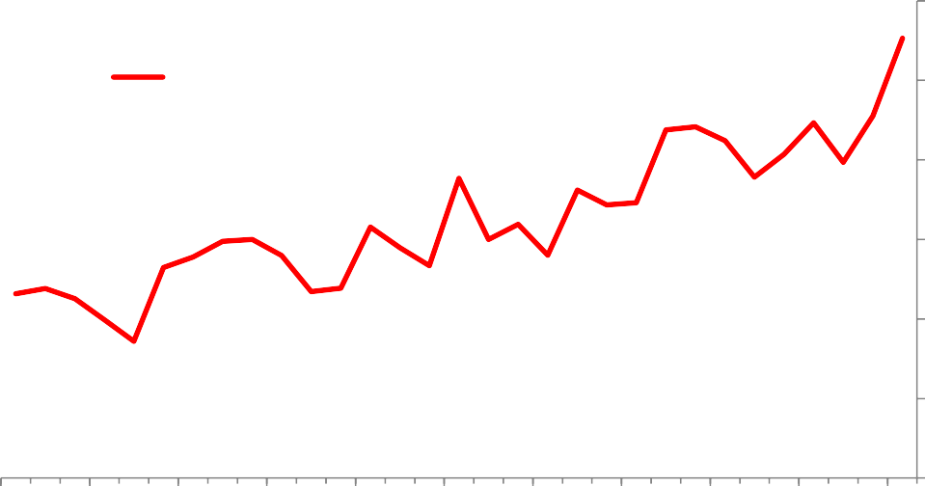

Mean (weighted by total sales)

1.6

1.5

1.4

1.3

1.2

1.1

1.0

1987 1990 1993 1996 1999 2002 2005 2008 2011 2014 2017

Sources: Thomson Reuters Worldscope and Bank calculations.

Note: Details of how mark-ups are estimated are described in the Appendix. Individual mark-ups are weighted by their share of total sales in the sample in a given year.

# Chart 4: UK market concentration and mark-ups

6

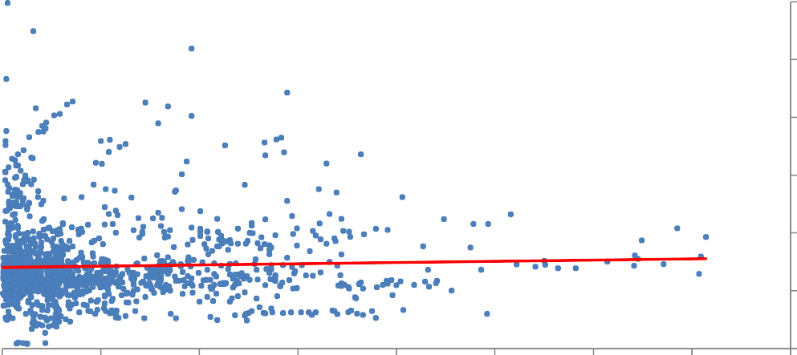

Sales-weighted markup (per cent)

y = 0.2132x + 1.4031 R² = 0.0014

5

4

3

2

1

0

0 0.1 0.2 0.3 0.4 0.5 0.6 0.7 0.8

Market concentration (HHI)

Sources: ONS, Thomson Reuters Worldscope and Bank calculations.

Notes: Data show market concentration and the average firm-level mark-up at the 2-digit sectoral level. The market concentration metric shown here, the HHI, is normalised to be between zero and one. While the relationship shown here – at the sector level – is only weakly positive, the relationship between firm-level mark-ups and the HHI is statistically significant in a regression when firm and time fixed effects are included. Mark-ups also exhibit a positive relationship with other broad measures of profitability, such as the dividends- to-sales ratio and the market capitalisation-to-sales ratio.

# Chart 5: UK-listed firms’ sectoral mark-ups

Mining and Quarrying Manufacturing Construction Wholesale and Retail Transport and Storage Accommodation

ICT

Professional, scientific and technical Administrative and support

Other service activities

Cumulative change in the mark-up since 1987 (Δ0.5=50pp)

1.0

0.8

0.6

0.4

0.2

0.0

-0.2

-0.4

Note: the Arts, entertainment and recreation sector is excluded.

1987 1990 1993 1996 1999 2002 2005 2008 2011 2014 2017

-0.6

Sources: Thomson Reuters Worldscope and Bank calculations.

# Chart 6: Banks’ net interest margins

Per cent

6

5

4

3

2

1

0

1996 2000 2004 2008 2012

UK Euro area US

Source: Federal Reserve Bank of St. Louis.

Notes: Data is sourced from the Federal Reserve Bank of St. Louis as that provides a consistent long-run international comparison of net interest margins. The broad post-financial crisis trend for UK banks in this data is consistent with the series for UK banks’ net interest margins published in the Bank’s *Inflation Report* in August 2016 (Chart C, Page 10).

# Chart 7: Contribution of changing sectoral composition to UK-listed firms’ mark-ups

Cumulative change in mark-up since 1987

0.4

0.3

0.2

0.1

0.0

-0.1

-0.2

1988 1992 1996 2000 2004 2008 2012 2016

Market share changes (sector) Mark-up growth (sector) Net entry (sector) Total change

Sources: Thomson Reuters Worldscope and Bank calculations.

# Chart 8: UK-listed firms’ mark-up distribution over time

90th percentile 70th percentile

Mark-up (e.g. 1.2 = 20%)

3

50th percentile

30th percentile

10th percentile

2.5

2

1.5

1

0.5

0

1987 1990 1993 1996 1999 2002 2005 2008 2011 2014 2017

Sources: Thomson Reuters Worldscope and Bank calculations.

# Chart 9: Mean and median UK-listed firms’ mark-ups

Mean (weighted by total sales) Median (weighted by total sales)

Mark-up (e.g. 1.2 = 20%)

1.6

1.5

1.4

1.3

1.2

1.1

1.0

1987 1990 1993 1996 1999 2002 2005 2008 2011 2014 2017

Sources: Thomson Reuters Worldscope and Bank calculations

# Chart 10: Skewness of UK-listed firms’ mark-up distribution by sector

**Mining and quarrying Manufacturing Transport and storage**

Skewness coefficient

6

5

4

3

2

1

0

Skewness coefficient

5

4

3

2

1

0

Skewness coefficient

4

3

2

1

0

-1

1987 1993 1999 2005 2011 2017

**ICT**

-1

1987 1993 1999 2005 2011 2017

**Construction**

-1

1987 1993 1999 2005 2011 2017

**Wholesale and retail**

Skewness coefficient

5

Skewness coefficient

5

Skewness coefficient

7

6

4 4

5

3 3 4

2 2 3

2

1 1

1

0

1987 1993 1999 2005 2011 2017

**Accommodation**

0

1987 1993 1999 2005 2011 2017

**Arts, entertainment and recreation**

0

1987 1993 1999 2005 2011 2017

**Administrative and support services**

Skewness coefficient

5

Skewness coefficient

2.0

Skewness coefficient

6

4 5

1.5

4

3

1.0 3

2

2

0.5

1 1

0

1987 1993 1999 2005 2011 2017

1987 1993 1999 2005 2011 2017

0.0

0

1987 1993 1999 2005 2011 2017

Sources: Thomson Reuters Worldscope and Bank calculations.

# Chart 11: Mark-ups for domestic and foreign-focussed UK-listed firms

Mean (weighted by international sales) Mean (weighted by domestic sales)

Mark-up (e.g. 1.2 = 20%)

2.0

1.9

1.8

1.7

1.6

1.5

1.4

1.3

1.2

1.1

1.0

1987 1990 1993 1996 1999 2002 2005 2008 2011 2014 2017

Sources: Thomson Reuters Worldscope and Bank calculations.

# Chart 12: UK-listed firms’ mark-ups and investment rates

Investment rate (per cent)

30

Increase in mean sales-weighted UK mark-up between 1987 and 2016

25

20

15

10

5

0

0 1 2 3 4 5 6 7 8

Mark-up (e.g. 1.5 = 50%)

Sources: Thomson Reuters Worldscope and Bank calculations. Investment function based around the firm-level regression in Table 2. ‘Investment rate’ defined as capital expenditure as a proportion of the previous year’s net property, plant and equipment level (PPE).

# Table 2: Regressions of investment, R&D and productivity on UK-listed firms’ mark-ups

**Investment rate Innovation rate Log TFP Log labour**

**productivity**

|  |  |  |  |  |
| --- | --- | --- | --- | --- |
| Log mark-up | 0.095*** | 0.023*** | 0.097*** | -0.036 |
|  | (0.027) | (0.009) | (0.026) | (0.045) |
| Log mark-up squared | -0.041** (0.017) | -0.018** (0.008) | 0.162*** (0.014) | 0.041  (0.034) |
| TFP distance | -0.002 | -0.000 | -0.054*** | -0.022** |
|  | (0.006) | (0.002) | (0.005) | (0.013) |
| Log mark-up * TFP |  |  |  |  |
| distance | -0.011 | -0.007** | 0.005 | 0.019 |
| (interaction term) | (0.012) | (0.003) | (0.006) | (0.013) |
| Log mark-up |  |  |  |  |
| squared * TFP distance (interaction term) | 0.018  (0.012) | 0.009*** (0.003) | -0.010** (0.004) | -0.018  (0.014) |
| Firm fixed effects | Yes | Yes | Yes | Yes |
| Time fixed effects | Yes | Yes | Yes | Yes |
| N | 21874 | 7386 | 28371 | 21268 |
| R2 | 0.058 | 0.057 | 0.305 | 0.054 |

Sources: Thomson Reuters Worldscope and Bank calculations.

Notes: Standard errors in parentheses; * p < 0.10; ** p < 0.05; ***p < 0.01

In regressions associated with columns 1 and 2, lagged Tobin’s Q and the lagged sales-to-assets ratio were included as controls. In regressions associated with columns 3 and 4, the terms involving TFP distance are lagged by one year.

‘Investment rate’ defined as capital expenditure as a proportion of the previous year’s net property, plant and equipment level (PPE). ‘Innovation rate’ defined as R&D expenditure as a proportion of the previous year’s total assets.

‘TFP’ defined as (the exponential of) the log of net sales, minus the log of cost of goods sold (COGS), log of net property, plant and equipment level (PPE) multiplied by their respective coefficients retrieved in the estimation of mark-ups, and minus the estimated measurement error..

‘TFP distance’ defined as the gap in a firm’s TFP from the most productive firm (in TFP terms) in a given year within the industry (measured at the 1-digit SIC level).

Labour productivity defined as sum of operating income (before depreciation, depletion and amortization costs) plus labour expenses (to capture value-added), divided by number of employees (in line with Imrohoroğlu and Tüzel (2014)).

To deal with outliers, and similar to De Loecker and Eeckhout (2018) and Díez *et al* (2018), we trim the top and bottom of 2% of observations for the investment rate, innovation rate, labour productivity and TFP before running regressions.

# Table 3: Regressions of labour share on UK-listed firms’ mark-ups

|  |  |  |  |
| --- | --- | --- | --- |
|  | **Log labour share** | **Log labour share** | **Log labour share** |
| Log mark-up | -0.094*** (0.019) | -0.093*** (0.024) | -0.067*** (0.020) |
| Log mark-up squared | -0.024  (0.019) |  | -0.033  (0.020) |
| Concentration |  | 0.061  (0.074) | 0.062  (0.073) |
| Log mark-up * concentration (interaction term) |  | -0.225  (0.151) | -0.233  (0.151) |
| Firm fixed effects | Yes | Yes | Yes |
| Time fixed effects | Yes | Yes | Yes |
| N | 21997 | 17218 | 17218 |
| R2 | 0.013 | 0.014 | 0.015 |

Sources: Thomson Reuters Worldscope and Bank calculations.

Notes: Standard errors in parentheses; * p < 0.10; ** p < 0.05; ***p < 0.01

Labour share defined as nominal wage bill divided by nominal value-added, where value-added is defined as the sum of operating income (before depreciation, depletion and amortisation costs) and labour expenses.

To deal with outliers, we trim observations where the measured labour share is less than zero or greater than one before running regressions.

|  |
| --- |
| **Chart 13: Impact of mark-up shock on annual inflation, output gap and policy rate** |
| **Annual inflation:** |
| **Output gap:** |

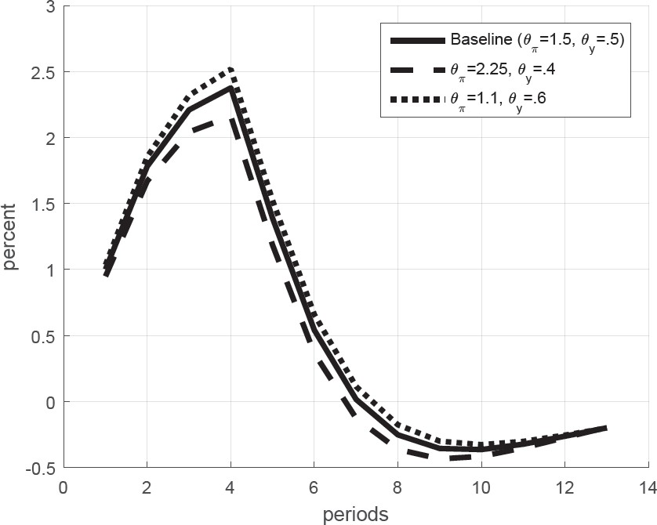

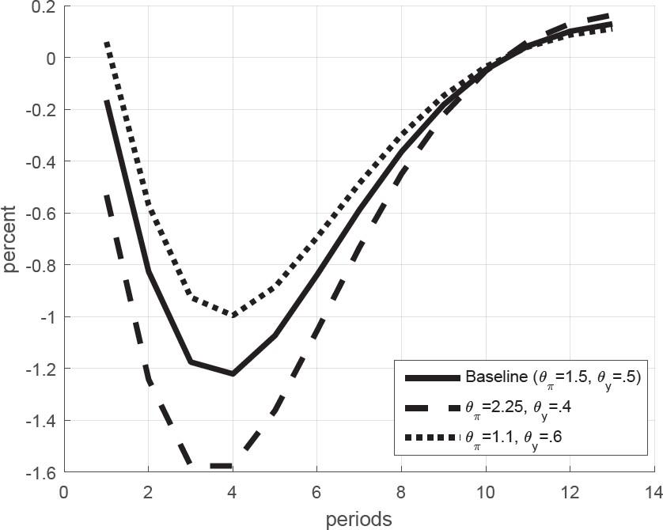

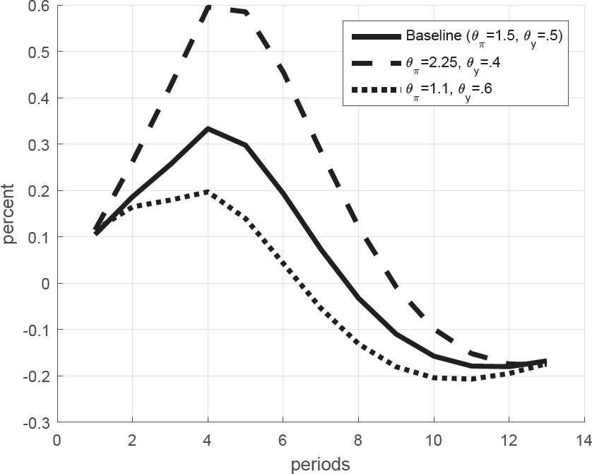

|  |
| --- |
| **Policy rate:** |
| Sources: Bank calculations.  Notes: COMPASS contains various mark-ups shocks. For simplicity, the shock shown here is the value-added mark-up shock. The qualitative implications would be little changed if other mark-up shocks were used instead. 𝜃𝜋 and 𝜃𝑦 show the weights placed on the deviation of inflation from target and the output gap in the Taylor rule, respectively. The Taylor rule also contains a lagged interest rate parameter to allow for interest rate smoothing. Charts here show the deviation of annual CPI inflation, output gap and the policy rate  relative to a baseline where no shock occurred. |

|  |
| --- |
| **Chart 14: Variability of inflation and output gap with and without mark-up shocks** |
| Sources: Bank calculations.  Notes: Chart shows the model-based variance of the inflation and the output gap for different calibrations of the Taylor rule, which alter the weight placed by the policymaker on deviations of inflation from target and output from potential. When moving from the baseline to the red markers, the various price mark-up shocks in the model are turned off. |

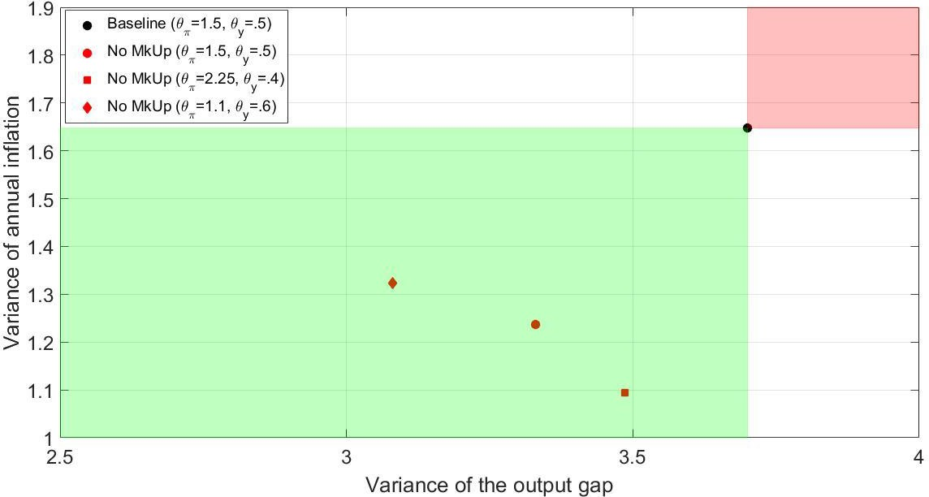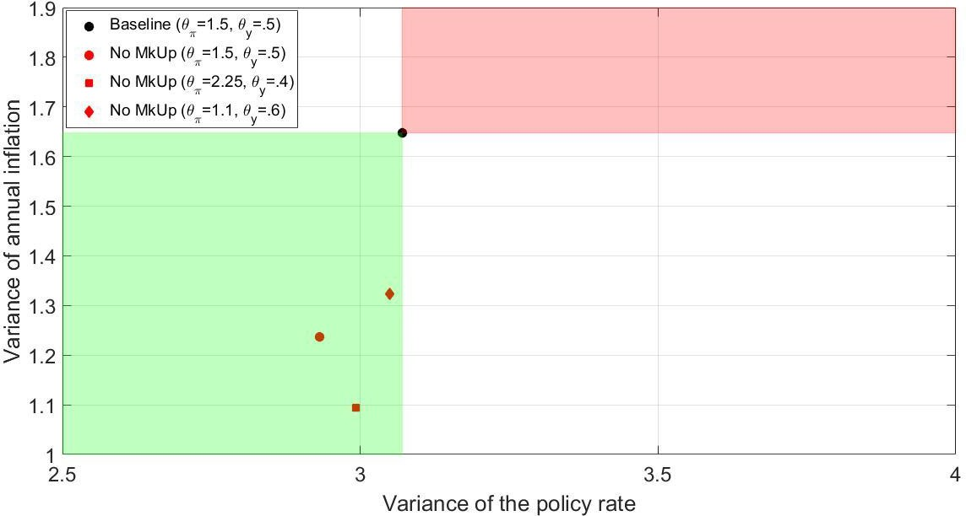

|  |
| --- |
| **Chart 15: Variability of inflation and policy rate with and without mark-up shocks** |
| Sources: Bank calculations.  Notes: Chart shows the model-based variance of the inflation and the output gap for different calibrations of the Taylor rule, which alter the weight placed by the policymaker on deviations of inflation from target and output from potential. When moving from the baseline to the red markers, the various price mark-up shocks in the model are turned off. |

# Chart 16: Mark-ups and the slope of the Phillips curve

Slope of Phillips curve

Estimated increase in global mark-ups

0.3

0.2

0.1

1.0

1.2 1.4 1.6 1.8 2.0

Mark-up level

0.0

Sources: De Loecker and Eeckhout (2018), Galí (2008) model and Bank calculations. Notes: Parametrisation such that 𝛽 = 0.99, 𝜃 = 2/3, 𝛼 = 1/3, 𝜑 = 𝜎 =1.

# Chart 17: Global mark-ups and real interest rates

3.5

3

2.5

2

1.5

1

0.5

0

Per cent Mark up

1980 1984 1988 1992 1996 2000 2004 2008 2012 2016

1

1.2

1.4

1.6

1.8

Laubach & Williams estimate of US natural rate of interest (LHS) Global mark-up (inverted, RHS)

Sources: Updated estimates from Laubach and Williams (2003) (available online), De Loecker and Eeckhout (2018) and Bank calculations.

Notes: Estimate of US natural rate of interest shown here uses annual averages of quarterly Laubach and Williams estimates. We would like to thank Jan De Loecker and Jan Eeckhout for kindly sharing their series of global mark-ups.

# Chart 18: Mark-ups and optimal policy weight on output stabilisation

Weight on output stabilisation

0.5

Estimated increase in global mark-ups

0.4

0.3

0.2

0.1

1.0

1.2 1.4 1.6 1.8 2.0

Mark-up level

0.0

Sources: De Loecker and Eeckhout (2018), Galí (2008) model and Bank calculations. Notes: Parametrisation such that 𝛽 = 0.99, 𝜃 = 2/3, 𝛼 = 1/3, 𝜑 = 𝜎 =1.

# Chart 19: Impact of mark-ups on inflation and output gap volatility

Standard deviation of inflation

20



Baseline

Higher mark-up shock variance

Higher mark-up shock variance and higher mark-ups

**D**

**B**

**A**

**C**

15

10

5

0

0 0.5 1 1.5 2 2.5 3 3.5 4 4.5

Standard deviation of output gap

Sources: Galí (2008) model and Bank calculations.

Notes: Parametrisation such that 𝛽 = 0.99, 𝜃 = 2/3, 𝛼 = 1/3, 𝜑 = 𝜎 =1. Standard deviation of mark-up shock increases from 0.1 to 0.125 when moving from the blue to red line. The steady-state mark-up level increases from 1.1 to 1.6 when moving from the red to the green line. The policymaker re-optimises 𝜆 when moving from point C to D.

# Chart 20: Impact of mark-ups on inflation and nominal interest rate volatility

Standard deviation of inflation

5

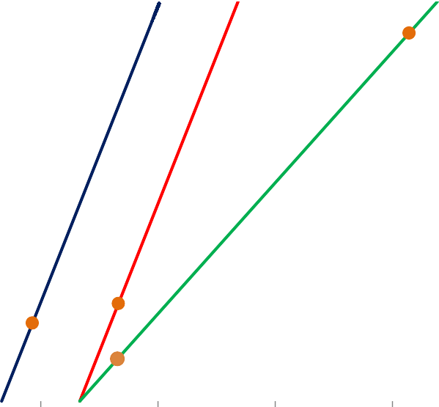

Baseline

**D**

Higher mark-up shock variance

Higher mark-up shock variance and higher mark- ups

**B**

**A**

**C**

4

3

2

1

0

0 1 2 3 4 5 6 7

Standard deviation of policy rate

Sources: Galí (2008) model and Bank calculations.

Notes: Parametrisation such that 𝛽 = 0.99, 𝜃 = 2/3, 𝛼 = 1/3, 𝜑 = 𝜎 =1. Standard deviation of mark-up shock increases from 0.1 to 0.125 when moving from the blue to red line. The steady-state mark-up level increases from 1.1 to 1.6 when moving from the red to the green line. The policymaker re-optimises 𝜆 when moving from point C to D.

# Chart 21: Mark-ups and inflation bias

Annualised inflation bias

40

Estimated increase in global mark-ups

30

20

10

0

1.0 1.2 1.4 1.6 1.8 2.0

Mark-up level

Sources: De Loecker and Eeckhout (2018), Galí (2008) model and Bank calculations. Notes: Parametrisation such that 𝛽 = 0.99, 𝜃 = 2/3, 𝛼 = 1/3, 𝜑 = 𝜎 =1.

# Appendix – estimation of firm-level mark-ups

To estimate firm-level mark-ups, we follow De Loecker and Eeckhout (2017, 2018) and Díez *et al* (2018), all of which are based on the original methodology proposed by De Loecker and Warzynski (2012).

Theory

Consider a firm 𝑖 at time 𝑡 that produces output with a production function whose arguments are variable inputs, capital, and technology.

Assume firms are cost-minimizers. Then, the Lagrangian associated with the cost minimisation problem (subject to the production function) leads to the following first-order condition for any variable input 𝑉 (free of adjustment costs):

𝑃𝑉 = 𝜆

𝑖𝑡

𝑖𝑡

(𝜕𝑄𝑖𝑡 (⋅)) (𝐴1)

𝜕𝑉𝑖𝑡

where 𝑃𝑉 is the input price of variable input 𝑉 faced by firm 𝑖 at time 𝑡, 𝜆𝑖𝑡 denotes the marginal cost of production, and (𝜕 𝑄𝑖𝑡(⋅)) denotes the marginal product of this input. Defining the mark-up as the ratio of price

𝑖𝑡

𝜕𝑉𝑖𝑡

to marginal cost, 𝜇𝑖𝑡 ≡ 𝑃 𝑖𝑡, we have that the above equation can be rearranged to give

𝜆

𝑖𝑡

𝜇 = 𝑃𝑖𝑡 (𝜕𝑄𝑖𝑡(⋅)) (𝐴2)

𝑃

We can rewrite this as

𝑖𝑡

𝑉

𝑖𝑡

𝜕𝑉𝑖𝑡

𝜇 = 𝑃𝑖𝑡 𝑄𝑖𝑡 (𝜕𝑄𝑖𝑡(⋅)) 𝑉𝑖𝑡 = (𝛼𝑉 )−1𝜃𝑉 (𝐴3)

𝑖𝑡

𝑖𝑡

𝑃𝑉 𝑉𝑖𝑡

𝜕𝑉𝑖𝑡

𝑄𝑖𝑡

𝑖𝑡

𝑖𝑡

where 𝛼𝑉 denotes the share of expenditures on input 𝑉𝑖𝑡 in total sales (𝑃𝑖𝑡𝑄𝑖𝑡), and 𝜃𝑉 denotes the output

𝑖𝑡 𝑖𝑡

elasticity of input 𝑉. This gives us an expression for the firm-level markup in terms of observable 𝛼𝑉 and the unobserved (but estimable) 𝜃𝑉. The procedure below is all about consistently estimating this output

𝑖𝑡

𝑖𝑡

elasticity.

Estimation

We generally follow De Loecker and Eeckhout (2017, 2018) and Díez *et al* (2018) in our empirical application of the theory above. The production function they take to the data is given by

𝑦𝑖𝑡 = 𝑓(𝑣𝑖𝑡, 𝑘𝑖𝑡; 𝜷𝑗) + 𝜔𝑖𝑡 + 𝜖𝑖𝑡 for all 𝑖 ∈ 𝑗 (𝐴4)

where 𝑖 indexes a firm and 𝑗 denotes a 2-digit SIC07 industry, lower cases denote logs, 𝑦𝑖𝑡 denotes deflated net sales, 𝑣𝑖𝑡 denotes deflated cost of goods sold (COGS) (which are taken to be a measure of variable inputs), 𝑘𝑖𝑡 denotes deflated net plant, property & equipment (PPE), 𝜔𝑖𝑡 denotes unobserved (to the econometrician) technology, and 𝜖𝑖𝑡 denotes the measurement error of net sales. Note that the production function parameters 𝜷𝑗 are assumed to be *industry-specific* and time-invariant.

We consider two specifications for 𝑓: Cobb-Douglas and translog. Under the former, the output elasticity with respect to COGS is exactly equal to 𝛽𝑣. Under the latter, the output elasticity with respect to COGS is equal

𝑗

to 𝛽𝑣 + 2𝛽𝑣𝑣𝑣𝑖𝑡 + 𝛽𝑣𝑘𝑘𝑖𝑡.

𝑗 𝑗 𝑗

A key challenge in estimating (A4) is the endogeneity of optimal input choices with respect to technology 𝜔𝑖𝑡. More precisely, whilst 𝜔𝑖𝑡 is unobserved to the econometrician directly, it is assumed to consist of two components: a part that’s *observable* to the firm (but not to the econometrician) and a part that’s *unanticipated* to the firm itself when it makes its input demand choices. The key identifying assumption is that we can express 𝜔𝑖𝑡 as a function of inputs (one of which is a so-called *control variable*, in our case COGS), i.e. 𝜔𝑖𝑡 = ℎ(𝑣𝑖𝑡, 𝑘𝑖𝑡). We don’t know what ℎ(⋅) is, but we can approximate it as a high-order polynomial (in our case, of order 2).

The estimation approach, which we run separately for all observations in a given 2-digit industry since 𝜷𝑗 are assumed to be industry-specific, relies on two stages:

*First stage*: In the first stage, we run a regression of 𝑦𝑖𝑗𝑡 on 𝑣𝑖𝑡, 𝑣2 , 𝑘𝑖𝑡, 𝑘2 , and 𝑣𝑖𝑡𝑘𝑖𝑡. Note that – to the extent

𝑖𝑡 𝑖𝑡

that 𝜔𝑖𝑡 depends linearly on 𝑣𝑖𝑡 and 𝑘𝑖𝑡 – the estimated coefficients on these two variables will subsume the coefficients corresponding to these inputs *and* how 𝜔𝑖𝑡 depends on them. This step allows us to control for unobserved productivity (up to our approximation) and obtain an estimate of expected output, 𝑦̂𝑖𝑗𝑡, and an estimate of the measurement error, 𝜖𝑖̂ 𝑡. Since we have arguably controlled for unobserved productivity, our 𝑦̂𝑖𝑗𝑡 should be a consistent estimate of 𝐸(𝑦𝑖𝑗𝑡).

*Second stage*: As mentioned earlier, to get the GMM moment conditions, we need to purge 𝜔𝑖𝑡 from its component observable to the firm. We assume 𝜔𝑖𝑡 follows an AR(1) process so that

𝜔𝑖𝑡 = 𝜌𝜔𝑖,𝑡−1 + 𝜉𝑖𝑡 (𝐴5)

where 𝜉𝑖𝑡 is an idiosyncratic, unobservable (to both the firm and econometrician) shock to technology. This is the part of 𝜔𝑖𝑡 that is assumed to be uncorrelated with optimal input choices and thus forms the basis for the GMM conditions. We know that our 𝑦̂𝑖𝑗𝑡 estimate subsumes both the inputs 𝑣𝑖𝑡, 𝑘𝑖𝑡 directly and indirectly through 𝜔𝑖𝑡 = ℎ(𝑣𝑖𝑡, 𝑘𝑖𝑡). But since it is consistent, we can express unobserved technology 𝜔𝑖𝑡 as a function of to-be-estimated 𝜷𝑗:

𝜔𝑖𝑡(𝜷𝑗) = 𝑦̂𝑖𝑗𝑡 − 𝑓(𝑣𝑖𝑡, 𝑘𝑖𝑡; 𝜷𝑗) (𝐴6)

So, given a 𝜷𝑗, we can estimate equation (A5) to back out 𝜉𝑖𝑡(𝜷𝑗). In the Cobb-Douglas case, we then have the GMM moment conditions

𝐸 (𝜉𝑖𝑡(𝜷𝑗) ( 𝑘𝑖𝑡

𝑣

𝑖,𝑡−1

)) = 0 (𝐴7)

Note that capital is assumed to be decided one period ahead and therefore should not be correlated with the innovation in productivity. We rely on *lagged* COGS to identify the coefficients on COGS since current COGS is expected to react to shocks to productivity and hence 𝐸(𝑣𝑖𝑡𝜉𝑖𝑡) is expected to be non-zero.

The GMM estimation thus boils down to searching for those 𝜷𝑗 that simultaneously minimise the sample moment conditions in (A7).

Once we have finally obtained 𝜷̂𝑗 from the above procedure, we can compute the output elasticity w.r.t. COGS 𝜃𝑉 (which is just equal to 𝛽𝑣 in the Cobb-Douglas case). In addition, we can use the estimated

𝑖𝑡 𝑗

measurement error in net sales, 𝜖𝑖̂ 𝑡, to adjust the denominator in the COGS share of net sales, 𝛼𝑉 . We can then compute our estimates of firm-level mark-ups 𝜇̂𝑖𝑡 = (𝛼̃𝑉 )−1𝜃̂𝑉 where 𝛼̃𝑉 is the measurement-error

𝑖𝑡

𝑖𝑡

𝑖𝑡

𝑖𝑡

adjusted (COGS/net sales) ratio, and 𝜃̂𝑉 is the estimated output elasticity with respect to COGS.

𝑖𝑡